ST. PIO MINISTRY OF VOCATIONS CHALICE
LET US, THE ST. PADRE PIO PARISH - ST. JOHN COMMUNITY,
JOIN IN PRAYER FOR RELIGIOUS VOCATIONS

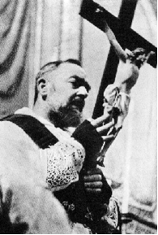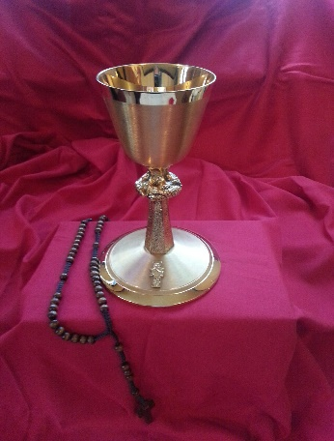
HISTORY OF THE ST. JOHN COMMUNITY VOCATIONS CHALICE

In 2011, St. John School children collected Pennies from Heaven to buy the vocations chalice. Since then, over 250 parish households have received it, as the Church struggles to increase the low number of priests and religious to serve God's people. It is dedicated to Pope Saint John Paul II who inspired so many vocations. A devoted recipient recently donated the beautiful portrait of St. Padre Pio, our patron, to hang in the Marian sanctuary, in Thanksgiving for his intercession.
The Chalice is in fact a third-class relic by touching the first-class relics of St. Pio’s blood stained cloth and St. Jean Vianney’s incorrupt heart. Photos are on the website respectively from his feast day Sept. 23, 2017 at St. Theresa in Trumbull CT and at Vocation Hour with Bishop Cote on Dec. 13, 2018, sponsored by the Knights of Columbus – Our Lady of Lourdes, Ledyard. Photos page 2.

PRAYER FOR THE INTERCESSION OF ST. PIO

Dear God, You generously blessed Your servant St. Pio with the gifts of the Spirit. You marked his body with the five wounds of Christ Crucified, as a powerful witness to the saving Passion and Death of Your Son. Endowed with the gift of discernment, St. Pio labored endlessly in the confessional for the salvation of souls. With reverence and intense devotion in the celebration of Mass, he invited countless men and women to a greater union with Jesus Christ in the Sacrament of the Holy Eucharist. Through the intercession of St. Pio, I confidently beseech You to grant me the grace of (here state your petition). Amen. Glory be to the Father…(three times).

For further details and signup form, go to stjohnstmark.org/vocations-chalice

Contact Barbara DiBella (860) 227-1215 to schedule a convenient week for you to accept the chalice into your home. A monthly carrier will call you on Wednesday prior to delivering the Chalice and prayer cards to your household on Saturday. You are welcome to invite friends to pray together with you during the week, before the carrier returns to take it to the next household.
BDiB 1/1/20

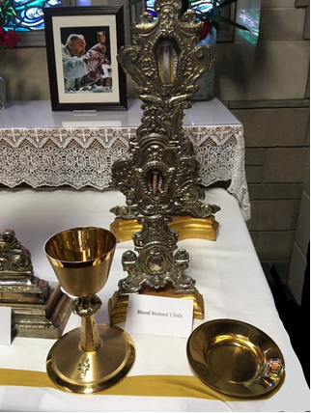

FIRST CLASS RELIC – ST. PIO BLOOD STAINED CLOTHE

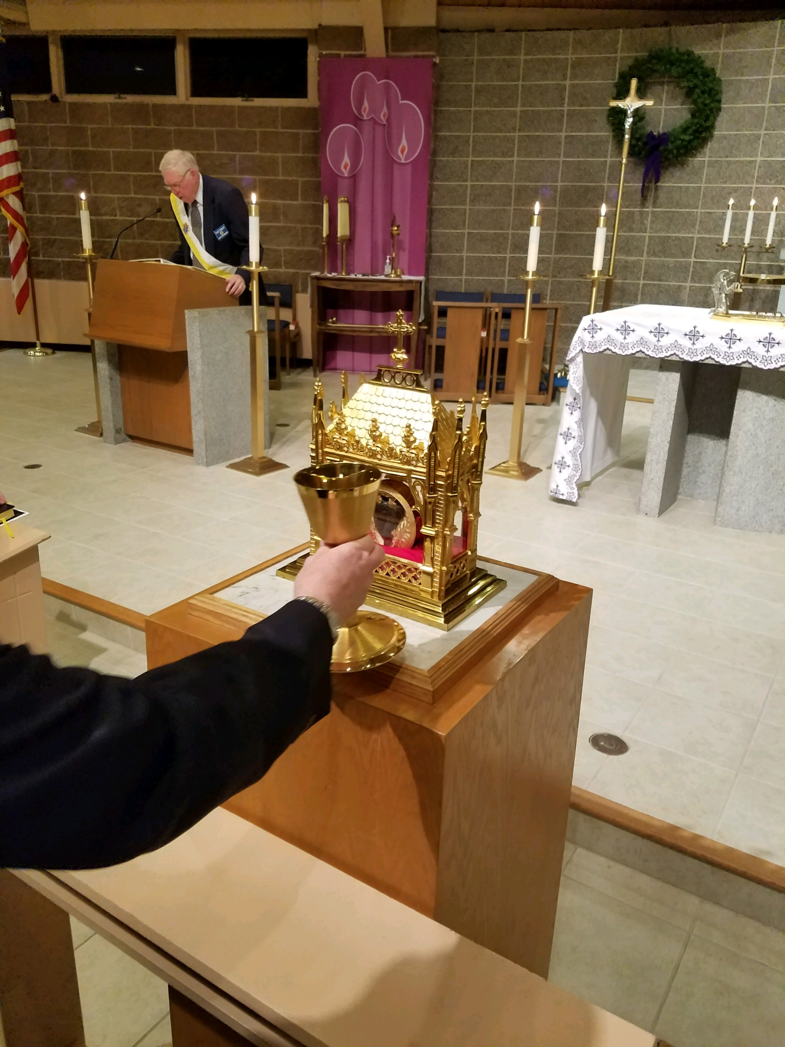

FIRST CLASS RELIC – ST. JEAN VIANNEY INCORRUPT HEART

